|  |
| --- |
|  |
| Critique of the UX Audit Cheat Sheet |
| Project 1: Evaluative Instrument Critique |
|  |
| **Veit, Desarae A**  Iowa State University |
| **2/9/2016** |

|  |
| --- |
|  |

## Purpose of Evaluative Instrument Critique

The purpose of this evaluation report is to evaluate the UX Audit Cheat Sheet (Natoli, 2015) to determine the strengths and weaknesses of using it as a tool for user interface design and development.

I was unable to find the names of the authors or publishers for this document.

# Purpose

An evaluation framework serves as a model for the evaluation plan (USAID, 2009). Developing a user experience (UX) framework and process plan helps to ensure the following objectives and sets a baseline for planning for future secondary objectives that are outside of the scope of this initial evaluation.

## **Outside of Scope** of Evaluative Instrument Critique

These items may have potential for future UX evaluation and research (Wikipedia, 2016).

1. Assist decision makers to establish the impact of implementing the UX Cheat Sheet
2. Determine the value of program improvement
3. Assist with ongoing progress, adaptation, and learning
4. Stimulate dialogue and expand knowledge base (Google, 2016)
5. Determine which effectiveness of the current documentation and program
6. Evaluation process for effectiveness and bottlenecks (Wikipedia, 2016)
7. Determine what are programs’ relative costs and benefits
8. Encourage the use of evaluation results to reflect positive change or mitigate risk
9. Make an informed judgment regarding the appropriateness of UX process integration
10. Identify user groups and separate results from administrative users
11. Track efficiency of mission-critical tasks and determine common behavioral patterns to improve process efficiency which will decrease wasted time, save money, and remove usability impediments
12. Determine common browsers used on a project so that QA may effectively test common browsers and resolution
13. Prove the risk of not integrating UX early and ongoing are the inability to ensure usability, accessibility, and waste of resources by not receiving ongoing stakeholder feedback

## **Defining Criteria** of Evaluative Instrument Critique

Defining criteria is a key component of any evaluation. The measurements and methods used to develop an evaluation closely relate to research. Research and evaluation methodology may also differ in critical ways like how an evaluator or researcher determines if their outcome is successful, who determines criteria, and which criteria are targeted. (Correia, 2016)

1. Determine appropriateness of the UX Audit Cheat Sheet to evaluate applications for quality and effectiveness
2. Determine strengths and weaknesses of the instrument as a user interface (UI) evaluation tool
3. Determine strengths and weaknesses of the instrument for evaluating accessibility (Wikipedia, 2016)
4. Determine what can be done to improve a UX Audit Cheat Sheet
5. Instill new ways of thinking by participating in an evaluation project

# Elements of Research

## Objective

The objective of this evaluation is to assist decision makers in determining the value and impact of integrating the UX Audit Cheat Sheet, Analytics, and a user-centered approach to UI/UX design processes to improve and modernize core UX processes, provide a streamlined UX process to support project plans, facilitate coordination to allow reviewers, analysts, and designers to efficiently make design decisions based on global standards (W3Schools, 2016) and relay those standards to quality assurances testers, project managers, and developers.

The implementation of UX validation checks and auditing documentation implemented early and ongoing in a project is important, but the UX Audit Cheat Sheet may be insufficient as a standalone tool. When UX is integrated early all the UX processes may be understood and integrated into project planning so that UX testing and UI design decisions can be managed effectively through a prescribed workflow. This allows reviewers and designers to make timely decisions and will eliminate the need for quality assurance and reviewers to perform additional non-routine analysis. Automation of the review process will ensure consistency, transparency, efficiency, and quality of UX testing. The UX Audit Cheat Sheet may also have practical applications in reviewing other documentation for accuracy and completeness including use cases, test cases, design artifacts, test cases, requirements, implementation documentation, and user guides.

## Task Work Description

Integration of the UX Audit Cheat Sheet and analytics into development teams’ project requirements will improve performance on mission-critical tasks. An evaluation will prove the importance of providing UX designers with analytics will improve efficiency in design, development, and quality assurance; which creates a business use case to ongoing progress adaption to offer measurable documentation.

### Strengths and Weaknesses Observation Study

#### Strengths of the UX Audit Cheat Sheet

The UX Audit Cheat Sheet is laid out in a **simple check-list format** with large fonts that are **easy to read**. The format includes **consistent headers** (W3schools, 2016) the correlate to a table of contents at the beginning of the document so sections can be quickly cross-referenced. The layout is consistent and the verbiage, content, and recommendations are in alignment with **web/accessibility standards**.

#### Weaknesses of the UX Audit Cheat Sheet

The **tone and verbiage** of the UX Audit Cheat Sheet is written for a beginner UX designer or someone who has some tech savvy, but should be easily recognizable to all designers, developers, and QA staff. It is not a document written for layman of software development. The document uses terms like trackpad, transcriptions, screen reader, and alt attributes that may easily be found in a web search and are very commonly used industry terms, but may be considered jargon to project management and key stakeholders. The content could easily be made more accessible for users with an elementary understanding of UX jargon, by including a glossary if the UX Audit Cheat Sheet is integrated into a common UX process flow, WIKI, or UX evaluation framework.

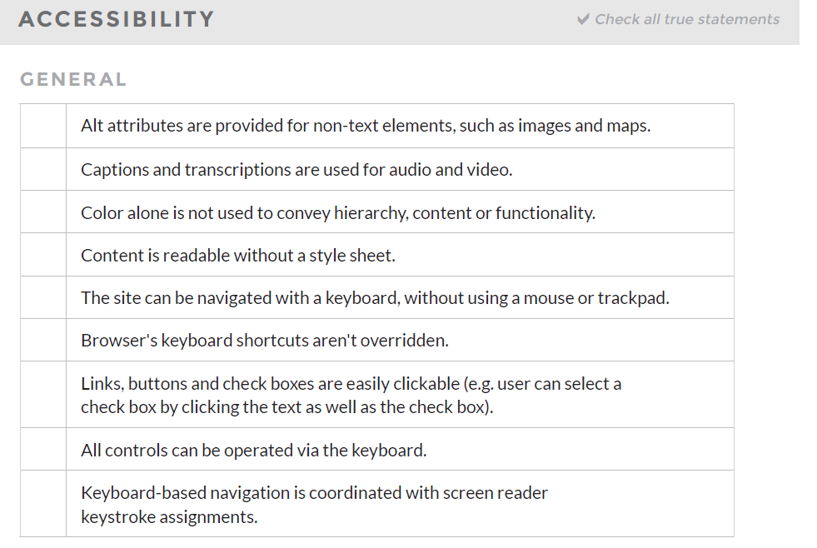

Figure 1 Give Good UX, UX Audit Cheat Sheet pg. 14

The UX Audit Cheat Sheet is **insufficient** as a standalone checklist for auditing EIT. It is almost too simple and could not be used as a stand-alone document to determine if a website or application is browser compatible, accessibility compliant, responsive, or aligns with web standards. Section 9, on accessibility is a good example of how incomplete the criteria of the UX Audit Cheat Sheet are; this section has 9 basic criteria (pictured in figure 1) for an electronic information technology (EIT) to be accessible. A quick Google search of the domain webaim.org reflects 51,600 results of indexed pages. Web Aim is a notable and highly respected resource for referencing web accessibility.

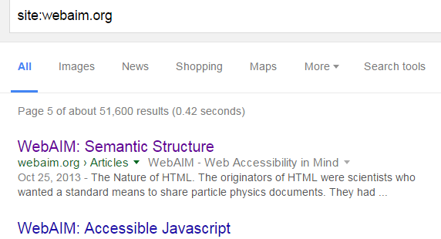

Figure 2 Google Search, WebAim.org

Most seasoned web development practitioners with government related experience or a business need for 508 compliance, ADA, WAI-ARIA, IndieUI, or WCAG compliance would know that content needs to be readable without a stylesheet. However, this phrase is too vague. Does that mean it needs to be formatted in the same order (a recommendation but not a compliance issue)? Does it mean that color should not be the sole conveyer of important information (this is a 508 compliance standard)? Perhaps it means the content should be 12-16px in a ‘readable’ font. The sentence structure is too subjective and open for interpretation. In design, it is nice to have freedom, but when a designer is trying to build EIT that is accessibility friendly and meets the latest web standards, this checklist may be too-open and doesn’t even reference actual guidelines/legislature. Many complex checklists are simplified down for readability (pre-flight checklists for aviation), but most require many hours of study and practice with an expert, testing, and reading books that are very thorough. Many also reference documents/resources for more information when necessary.

# Conclusions of Evaluative Instrument Critique

An evaluation of process improvement is essential to developing an understanding of what works, the efficiency of current methods, and to be able to document inaccuracies or missing components. The results of this evaluation will lead to an understanding of why additional research is needed to create a report, case studies, and UX initiative intended to set a foundation for an overall development framework and design standards.

Future evaluation should be done regarding current UX process flows and the benefit of implementing a new process flow that addresses integrating 508 compliance, ADA, WAI-ARIA, IndieUI, WCAG compliance, and the UX Audit Cheat Sheet to create a complete test plan, case studies, and implementation documentation.

Overall, the UX Audit Cheat Sheet is a well laid out and beautiful checklist but is an ineffective tool when used as a standalone technique for checking web quality assurance based on web standards and other commonplace compliance standards.

## Recommendations

Lessons learned from this evaluation may be implemented into multiple programs for overall process improvement, efficiency, risk mitigation, and to improve resource management by decreasing the need for calls to help desk, time on pages (bandwidth), and time to production (managerial and development resources). For these results to be effective the UX process plan and Analytics would need to be integrated early into business requirements and schedules by program/project management.

A complete set of documentation based on future research could result in a WIKI, implementation documentation, and process flows that would successfully allow project managers to plan, budget, and integrate UX.

According to the USAID (2009) evaluation framework for USAID-funded TIP prevention and victim protection programs

Possible methods for assessing the impact and determine value of implementing the UX Cheat Sheet may include (Please note that one or more of these activities may be nearly impossible to implement without analytics):

1. Expand lists to a comprehensive list of each section
2. Build a wiki with descriptions for beginners
3. Cross reference or identify how to implement checklist suggestions
4. Include references to 508 compliance under the accessibility section
5. Include a section on WCGA 2 standards under accessibility
6. Include code examples
7. Include a section on navigation, skip navigation, and breadcrumbs (W3schools, 2016)
8. A/B Testing of designs or budget variance on two or more similar programs
9. Performance testing of mission-critical behavioral plans before and after optimization
10. Integration of feedback forms within help documentation
11. Implement documentation about tracking help documentation, searched keywords, and pages visited prior to help documentation to determine efficiency of process flows, create personas, improve searchability/accessibility, and
12. Integrate eye tracking and heat maps into user testing and QA programs to evaluate how users interact with the program to identify usage patterns, behaviors, and identify points of interest

## Future Work Potentially Connected To Findings

1. Determine the quality of the implemented process
2. Determine the feasibility of a training plan and effectiveness of internal knowledge sharing
3. A formative assessment on UX/Analytics implementation where summative results have been implemented on an overall program’s strategy
4. Determine which effectiveness of documentation and program
5. Evaluate cost and benefits ongoing
6. Determine additional stakeholders or specific program stakeholders per project
7. Determine risks associated with implementation
8. Documentable Outputs, Outcomes, and Impacts
9. Investigable Costs and BenefitsList of Terms and Acronyms

|  |  |
| --- | --- |
| Term | Meaning |
| 508 Compliance | Section 508 of the Rehabilitation Act, §1194.22 is a set of guidelines, rules, and best practices set forth for EIT to ensure all users, regardless of disability status, can access technology. |
| Accessibility | Accessibility refers to the design of products, devices, services, or environments for people with disabilities. The concept of accessible design ensures both "direct access" (i.e. unassisted) and "indirect access" meaning compatibility with a person's assistive technology (for example, computer screen readers). (Wikipedia, 2016) – It is important to note that accessibility is not always the same as compliance regulations. |
| Baseline | The initial measurement of a performance indicator is used to learn about current levels and patterns of performance before the program intervention. It sets the current condition against which future change can be tracked (Kusek, 2004). |
| Beneficiaries | The individuals, groups, or organizations that benefit from the program intervention (Kusek, 2004). Direct beneficiaries may be those who receive training or services. Indirect beneficiaries may be those treated by trained staff, or the families and colleagues of those who received services. (USAID, 2009) |
| Classical Experimental Design | An experiment with random assignment of subjects to experimental and control groups with a pretest and a posttest for both groups (Angelo, 2016). The evaluator constructs identical treatment and control groups. The treatment group receives the intervention; the control group does not (USAID, 2016). |
| Content | The aesthetics or text displayed onscreen of an application; may include video, animations, and hidden elements for screen readers, text, images, tags, meta data, sounds, buttons, video, and links. For the purpose of this evaluation, content is described as either text content or non-text content. |
| Data | Individual facts, opinions, attitudes, or items of information (IOM, 2008). |
| EIT | Electronic information technology |
| Evaluation | The systematic and objective assessment of an on-going or completed project, program or policy, its design, implementation and results. The aim is to determine the extent of implementation, efficiency, effectiveness, impact and/or sustainability, on or for a variety of targets or purposes (IOM, 2008). |
| Evaluation Framework | A map for carrying out an assessment of program work, measuring both the extent to which the program has implemented its planned activities and the extent to which the activities have resulted in achieving the intended objectives. A framework differs from an evaluation plan in that it does not spell out the details of implementing an evaluation for a given program. (USAID, 2009) |
| Feedback | Reactions to the design, process, performance, task, pathway, flow may be directed through direct or indirect methods (verbal interview, analytics, forms) |
| Formative Evaluation | A type of evaluation conducted during the course of program implementation whose primary purpose is to provide information to improve the program under study (Weiss, 1996). |
| Goal | A single statement of the broader aim of a program, i.e., how the program can contribute to a larger national or international development plan or action (IOM, 2008). Goal is something which we strive to achieve. Purpose is something that influences goal. Purpose is the reason for achieving the goal. Objective is the specific action which one tries to achieve as a short term plan. (Sravya, 2015) |
| Impact | Positive and negative, primary and secondary, long-term effects produced by a program intervention, directly or indirectly, intended or unintended (Kusek, 2004). Achieving impact is a broader, more difficult criterion than producing outcomes which is, again, a higher bar than producing outputs. (USAID, 2009) |
| Interaction | Engagement with web content |
| Indicators | Quantitative and qualitative factors or variables that provide a simple and reliable means to measure achievement, to reflect the changes connected to an intervention, or to help assess the performance of the program (Kusek, 2004). |
| Inputs | The financial, human, and material resources use for the program intervention (Kusek, 2004). |
| Intervention | Activities funded and implemented in order to have an impact on an identified problem, such as trafficking in persons. |
| Knowledge Base | A collection of information in a shared location for team members to draw on. May also be considered a set of facts, assumptions, and rules used to solve a problem (Google, 2016). |
| Labeling | Definitions and hierarchy for attributes and elements. Some labels do not render anything visually special for the user, but may offer usability improvement for mouse/keyboard users and users who rely on eReaders (like JAWS). HTML attributes give elements meaning and context. (W3schools, 2016) |
| Logic Model | A management tool used to improve the design of interventions, most often at the project level. It involves identifying the strategic elements (inputs, outputs, outcomes, impact) and their causal relationships, performance indicators, and the assumptions or risks that may influence success or failure. It thus facilitates planning, execution and evaluation of a program intervention (Kusek, 2004). |
| Monitoring | A continuing function that uses systemic collection of data on specified indicators to provide management and the main stakeholders of an ongoing program intervention with indications of the extent of progress and achievement of program objectives (Kusek, 2004). |
| Navigation | Elements in a menu of web content to help a user navigate an individual or group of interconnected websites or applications. |
| Objective(s) | The specific, desired program outcomes (Kusek, 2004). Objectives should be tied to the overall goal of the program, and be situated within a realistic appraisal of potential accomplishments given what others have been able to do, or what has been accomplished previously |
| Operationalize | To translate general program inputs, processes, and goals into specific, measurable benchmarks and performance indicators (Weiss, 1996). |
| Outcomes | The likely or achieved short-term and medium-term effects of an intervention's outputs (Cusec, 2004). Outcomes should reflect the results of program activities and their impact on program goals. However, outcomes may not be broad enough to yield impact on addressing the problem of trafficking overall. (USAID, 2009) |
| Outputs | Direct and measurable results expected from program activities. They should be tangible, visible and measurable outputs of program work. If they are sustainable beyond the activity, they may turn into program outcomes and have impact on the problem of trafficking overall (IOM, 2008). |
| Performance Indicators | Pre-determined measurements that track specific changes or outputs of a program. Performance indicators are directly linked to measuring progress toward program objectives and are often a combination of monitoring and evaluation (IOM, 2008). Interim performance indicators are called benchmarks. |
| Process Evaluation | A study of what goes on while a program is in progress. Process evaluation relates to the phase of the program studied – in this case, program implementation (Weiss, 1996). |
| Program Audit | An independent, objective assurance activity designed to add value and improve a [program's] operations. Performance auditing is concerned with relevance, efficiency, and effectiveness (Kusek, 2004). |
| Research | Testing theory and producing generalizable finding for contribution to knowledge based on the scholar’s discipline. (Patton, 2014) |
| Search | A tool to allow users to find content within the context of a document, program, website, or application. Often uses an input field and database of keywords/sectional algorithm to increase the likelihood that a user finds expected/related content. |
| Selection Bias | The bias resulting from preexisting differences between program participants and the comparison group. Effects found at the conclusion of the evaluation may be due to the fact that different types of people were selected or selected themselves into the program and comparison groups (Weiss, 1996). |
| Stakeholders | Agencies, organizations, groups or individuals who have a direct or indirect interest in program work and outcomes there from, and who are affected positively or negatively by the implementation of activities (IOM, 2008). |
| Summative Evaluation | A study conducted at the end of a program (or of a phase of a program) to determine the extent to which anticipated outcomes were produced. Summative evaluation is intended to provide information about the worth of the program (Weiss, 1996). |
| Theory of Change | The assumptions that link a program’s inputs and activities to the attainment of desired ends; it include both implementation theory and program theory (Weiss, 1996). |
| USAID | U.S. Agency for International Development |
| UI | User Interface or front-end design and development is the process of making creative layouts and front-end code for software applications |
| UX | User Experience Design (UXD or UED or XD) is the process of enhancing user satisfaction by improving the usability, accessibility, and pleasure provided in the interaction between the user and the product. (Wikipedia, 2016) |
| QA | Quality Assurance |

# References

*Joint Committee on Standards for Educational Evaluation* (2016). <http://www.jcsee.org>

United Nations World food Programme. (n.d.). Monitoring and evaluation guidelines: How to plan a baseline study. Rome, Italy: UNWFP Office of Evaluation and Monitoring.

Bamberger, M., Rugh, J., and Mabry, L. (2006). Real world evaluation: Working under budget, time, data, and political constraints. Thousand Oaks, CA: Sage Publications, Inc.

United Nations Population Fund. (2004). Programme manager’s planning, monitoring and evaluation toolkit. New York, NY: UNFPA Division for Oversight Services.

Kusek, J.Z. and Rist, R.C. (2004). Ten steps to a results-based monitoring and evaluation system. Washington, DC: The International Bank for Reconstruction and Development/The World Bank.

Centers for Disease Control and Prevention. (2008). Introduction to process evaluation in tobacco use prevention and control. Atlanta, GA: U.S. Department of Health and Human Services, Centers for Disease Control and Prevention, National Center for Chronic Disease Prevention and Health Promotion, Office on Smoking and Health.

United States Agency for International Development [USAID]. (2009). An evaluation framework for USAID-funded TIP prevention and victim protection programs. Social Transition Team, Bureau for Europe and Eurasia. <http://pdf.usaid.gov/pdf_docs/Pnadr431.pdf>

Saunders, R.P., Evans, M.H., Joshi, P. (2005). Developing a process-evaluation plan for assessing health promotion program implementation: A how-to guide. Health Promotion Practice.

Weiss, C.H. (1997). Theory-based evaluation: Past, present, and future. New Directions for Evaluation.

Fitzpatrick, J., Sanders, J. & Worthen, B. (2011). *Program Evaluation: Alternative Approaches and Practical Guidelines (4th ed.),* Chapter 1. *New York: Pearson.*

*American Evaluation Association* (2016). <http://www.eval.org/>

Rutgers, New Jersey Agricultural Experiment Station (Ed.) (2016). Conducting Needs Assessments: Program Evaluation Resources. *Rutgers Website.* <http://njaes.rutgers.edu/evaluation/resources/needs-assessment.asp>

Newby, A.C. (1992). Training Evaluation Handbook, London: Gower.

Mark Spilsbury (1995). Measuring the Effectiveness of Training.

Kirkpatrick, D. (1998). Evaluating Training Programs: The Four Levels (2nd ed). *San Francisco: Berrett-Koehler* (pp. 19-24). <https://bb.its.iastate.edu/webapps/blackboard/execute/content/file?cmd=view&content_id=_2689437_1&course_id=_48572_1>

Newby (1992). Training Evaluation Handbook, (Chapters 1-2). <https://bb.its.iastate.edu/webapps/blackboard/execute/content/file?cmd=view&content_id=_2689438_1&course_id=_48572_1>

Pei, Z. (2007). NSF CAREER Proposal Writing Tips . In G. A. Hazelrigg. Kansas State University, National Science Foundation, (pp. 9). <http://aries.imse.ksu.edu/nsf/nsfcareer2012/subfolder/career.pdf>

The OWL (2016). APA Sample Paper. Purdue University, (pp. 1-2). <https://owl.english.purdue.edu/owl/resource/560/18/>

Correia, A.-P. (2016). *The Big Picture Part 1 504 Class Discussion Slides*. Retrieved 2016, from Blackboard: https://bb.its.iastate.edu/bbcswebdav/pid-2690927-dt-content-rid-29068153_1/courses/S2016-C_I__-504_-NONE/the%20big%20picture_Part1_Class%20discussion.pdf

Google. (2016). *Define Knowledge Base Search.* Retrieved 2016, from Google: https://www.google.com/webhp?sourceid=chrome-instant&ion=1&espv=2&es_th=1&ie=UTF-8#q=define+knokwledge+base

Natoli, J. (2015, October 5). *UX Audit Cheat Sheet.* Retrieved January 5, 2016, from Give Good UX: http://www.givegoodux.com/wp-content/uploads/2015/08/UX-Audit-Cheat-Sheet-GGUX.pdf

Patton, M. Q. (2014). *Evaluation Flash Cards: Embedding Evaluative Thinking in Organizational Culture.* Retrieved from http://www.ottobremer.org/sites/default/files/fact-sheets/OBF_flashcards_201402.pdf

Pei, Z. (2007). NSF CAREER Proposal Writing Tips . In G. A. Hazelrigg. Kansas State University, National Science Foundation .

Sravya, G. (2015). *What's the difference between goal, purpose and objective?* Retrieved from https://www.quora.com/Whats-the-difference-between-goal-purpose-and-objective

The OWL, P. U. (2016). APA Sample Paper. 1-2.

W3schools. (2016, January). *Breadcrumbs*. Retrieved from http://www.w3schools.com/bootstrap/tryit.asp?filename=trybs_ref_comp_breadcrumb

W3Schools. (2016). *Global Attributes*. Retrieved January 2016, from W3Schools: http://www.w3schools.com/tags/ref_standardattributes.asp

W3schools. (2016). *Headers.* Retrieved January 10, 2016, from http://www.w3schools.com/tags/tag_header.asp

W3schools. (2016). *Labeling.* Retrieved 2016, from http://www.w3schools.com/tags/tag_label.asp

Wikipedia. (2016). *Evaluation.* Retrieved 2016, from Wikipedia Website: https://en.wikipedia.org/wiki/Evaluation

Wikipedia. (2016). *Accessibility.* Retrieved 2016, from https://en.wikipedia.org/wiki/Accessibility

Wikipedia. (2016). *User Experience Design*. Retrieved from https://en.wikipedia.org/wiki/User_experience_design